Aunuu Elementary School Access Road
This road begins from the wharf and runs along the shore heading towards the elementary school with a width of 16-feet and a total length of approximately 2,667 Linear Feet. The scope of work includes the construction of:

- Two (2) 8-Feet wide PCC paved lands (Bi-Directional)
- New 4-Feet wide sidewalk on the left hand side (LHS)
- Improvement of the existing access sidewalk within the village
- Relocation of existing power poles
- CRM retaining wall with guardrail for embankment stabilization

Duration of project: 270 calendar days
Total cost of project: $1,299,933.15
Contractor: Tony’s Construction
Funded by: U.S. DOT
Federal Highway Administration

Route 001 – Nuuuli Village Shoreline Protection

This project consists of shore protection approximately 250 Linear Feet from the Coconut Point Road to prevent shore erosion and scouring due to wave action. The Scope of Work includes the construction of:

- 1-ton triar units placed on top of a double layer of 100-300 lbs. underlayer rocks
- Construction of concrete rubble masonry (CRM) tie back structure and retaining walls
- Installation of three (3) access stairs, two (2) 18-inch diameter pipe culvert drainage outlets, and an open channel to convey overland runoff

Duration of project: 240 Calendar days
Total cost of project: $1,162,428.37
Contractor: Continental Transport Corp.
Funded by: U.S. DOT
Federal Highway Administration

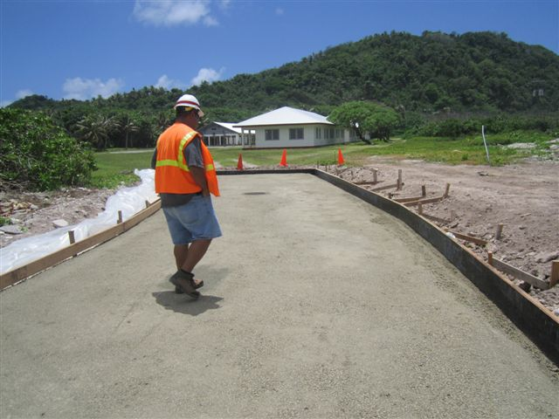

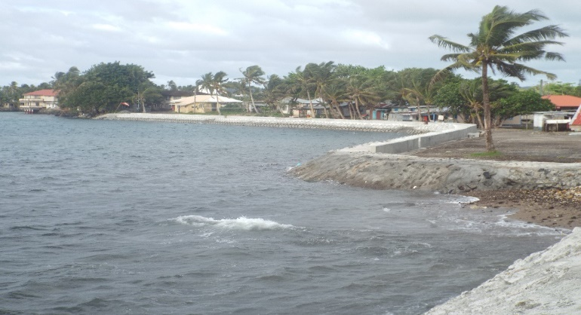

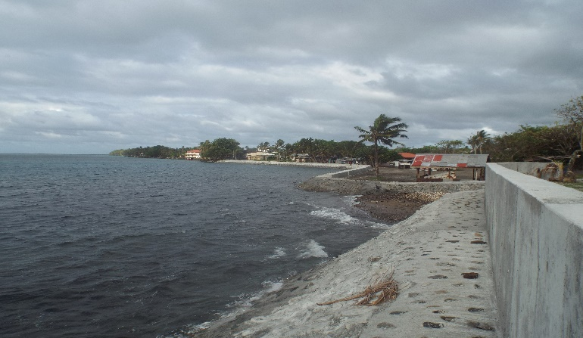

Route 001 – Aua Village Shoreline Protection

This project is for 1090-Linear Feet of potentially critical to critical section of shoreline divided into three (3) sections. The Scope of Work includes the construction of:

- A single layer revetment (Armor Rocks) and a double layer of underlayer rocks
- Cement Rubble Masonry (CRM) tie back structures and retaining walls
- Installation of access stairs, 18-inch diameter pipe culvert drainage outlets
- Section one consists of approximately 600-Linear Feet of shoreline protections from the existing boat house heading east
- Section two consists of approximately 325-Linear Feet of shoreline protection adjacent the Suaa stream
- Section three consists of approximately 325-Linear Feet of shoreline protection adjacent Tagalu’s guest house heading east

Duration of project: 270 Calendar days
Total cost of project: $845,734.78
Contractor: Happy Trucking
Funded by: U.S. DOT
Federal Highway Administration

Route 009 – Leone Village Bridge Project

The Leone Village Bridge was damaged during the September 2009 Earthquake and Tsunami. The Scope of Work for this project includes the construction of:

- New bridge replacing the damaged bridge following the existing alignment
- A temporary bridge structure to maintain vehicle traffic
- Road pavement and/or realignment
- Utility relocation
- Clearing and/or grading, erosion protection, drainage improvements and miscellaneous works such as removal of trees, revetment, etc.

Duration of project: 17 months
Total cost of project: $5,365,609.72
Contractor: McConnell Dowell Ltd. AS
Funded by: U.S. DOT
Federal Highway Administration
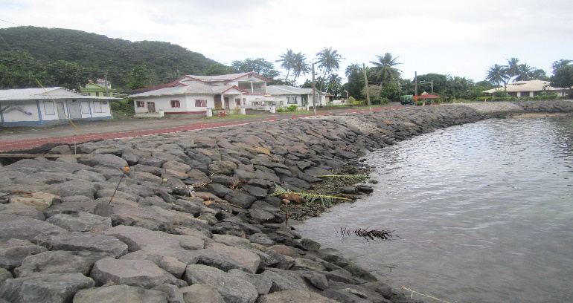

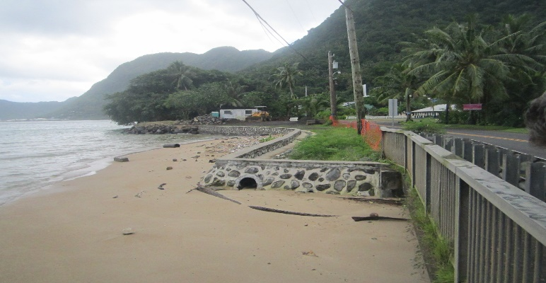

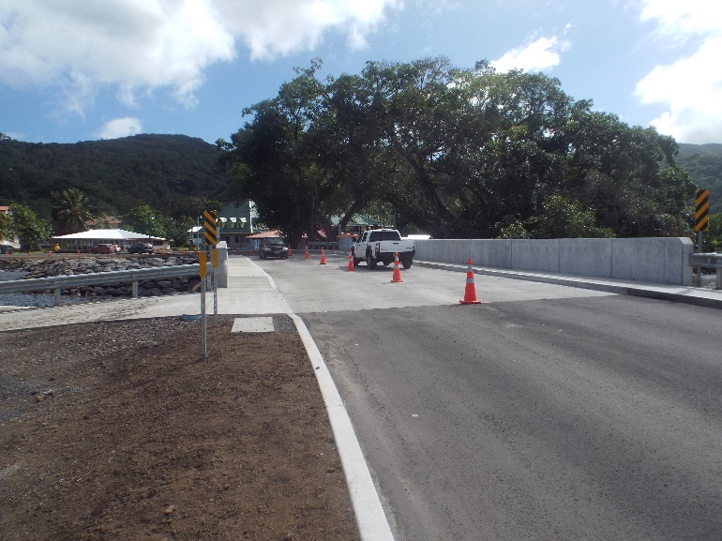

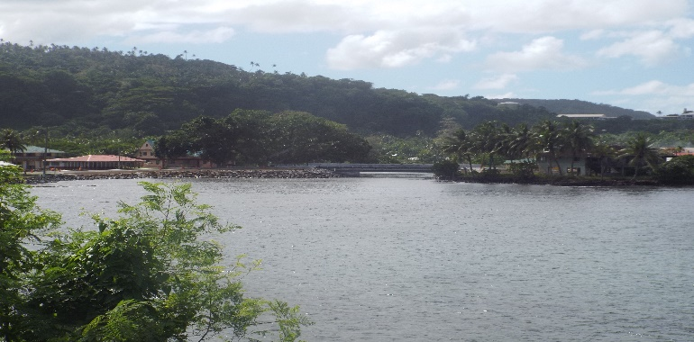

Leone Culvert
This project is a construction of a 12'W x 20 ft. L x 6 ft. D culvert crossing. The structure is a three leg (stiffleg) culvert reinforced concrete one lane vehicle access to the other side of the stream. Grouted riprap paving is also proposed as the bottom protection of the culvert foundation including culvert apron at the inlet and outlet side of the culvert to prevent scouring. A 10 ft. length by 12 ft. wide Portland Cement Concrete Pavement (PCCP) will also be in-placed to the approach of the culvert for better transition to the existing road. Also, included is a Cement Rubble Masonry (CRM) on both sides of the culvert structure at the bank for erosion protection.
Duration of project: 2 months
Total cost of project: $50,000.00
Contractor: DPW M & O
Funded by: Governor’s Special Programs

Ferry Vessel – Segaula

This project is a 39’ Catamarran boat with a beam of 15’. It has a forward leaning walk through cabin with a sun/boat deck and fly-bridge helm station. It seats 18 indoor passengers and 15 outdoor passengers. It is controlled by electronic shift throttle actuation with a 20gal. capacity Northern Lights diesel generator. It has Dual Garmin 200i VHF radios and is navigated by Garmin 6212 Chartplotter and 18” HO Radar dome. Its engine is a 4 X 225HP Mercury Verado outboard motors and an unleaded gasoline of 300 gallons capacity. This boat was built in Port Angeles, Washington.

Duration of project: 12 months
Total cost of project: $795,000.00
Contractor: Armstrong Marine
Funded by: U.S. Federal Transit Administration (FTA)

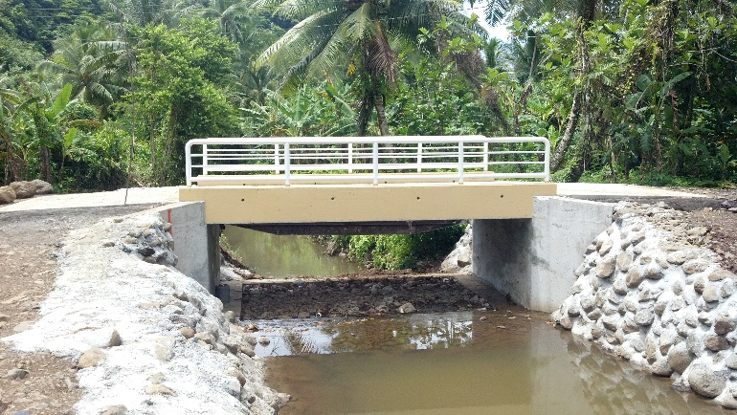

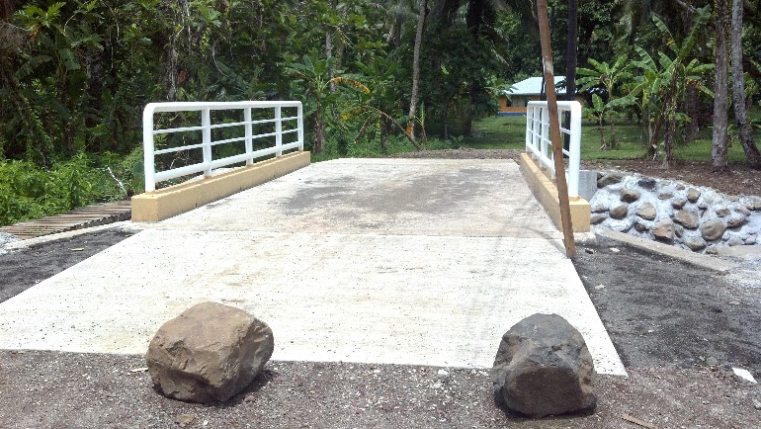

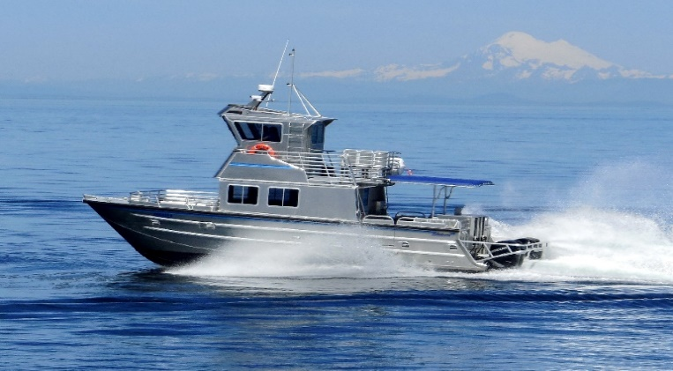

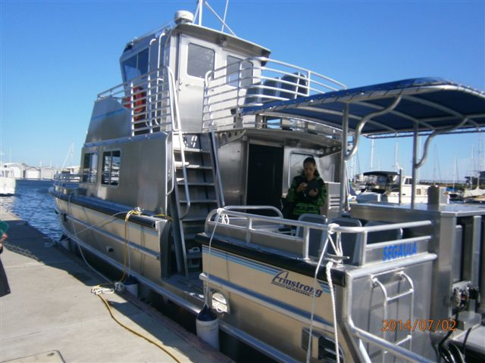

Leone Midkiff Elementary School

This project is a 2-Story building consisting of four (4) classrooms on the second level. At the ground level, there’s a dining room and kitchen. It also has an elevator for disabled individuals in complying with the requirements of the American Disabilities Act (ADA).

Duration of project: 6 months
Cost of project: $1,600,000.00
Contractor: Fletcher Construction
Funded by: HUD - CDBGE

Leone High School – Building A

This project consists of a 2-Story building at the end of campus nearest the green house. It has five (5) classrooms per story for a total of 10 classrooms. There’s a second story veranda and two (2) exit stairs. The second level connects to an adjacent existing 2-story building via a covered walkway. Each classroom is about 765 sf in area.

Duration of project: 2 years
Cost of project: $859,000.00
Contractor: Hollister
Funded by: DOI - Capital Improvement Projects (CIP)

Leone High School – Building B

This project is a 2-Story building located between two existing round classroom structures and adjacent to the campus office. It consists of three classrooms and a resource center at its ground level. The second level consists of five classrooms and a veranda with two exit stairs and a disabled accessible ramp to comply with the ADA and Title III requirements. It is constructed to withstand Category 5 hurricanes or cyclones.

Duration of project: 16 months
Cost of project: $845,630.79
Contractors: Wulf / Fletcher
Funded by: DOI – Capital Improvement Projects (CIP)

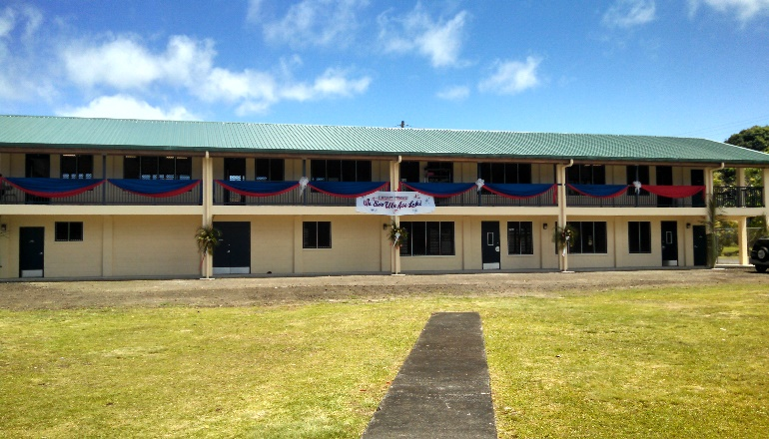

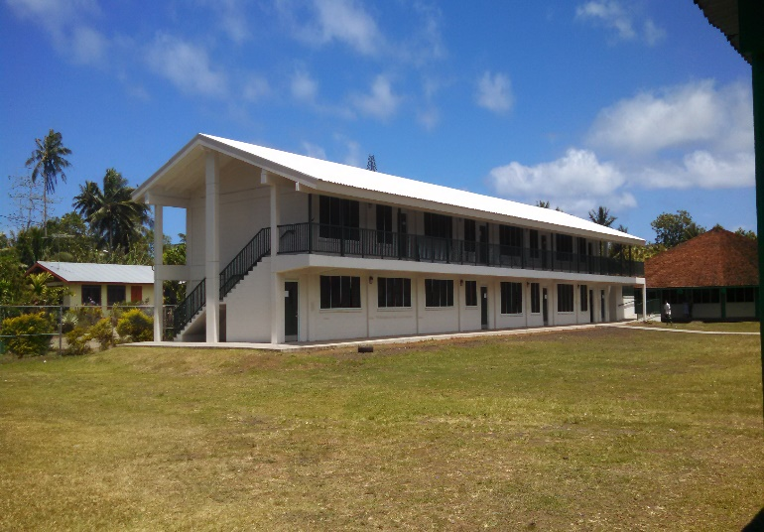

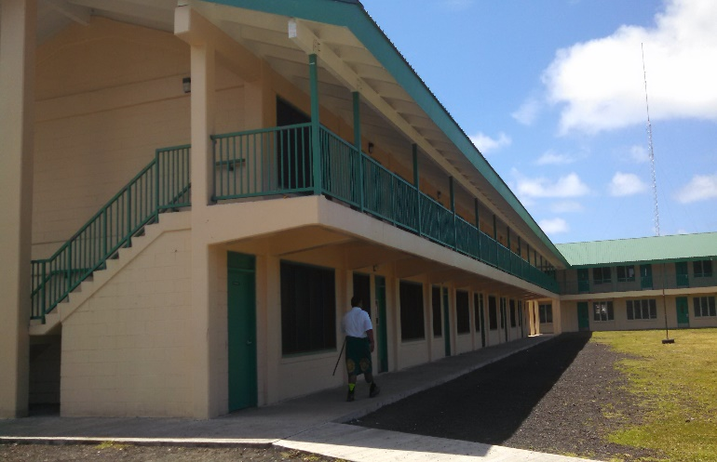

VA Stadium

This project is an extension to the existing rear bleachers. It is an enclosed gym building with an open interior used for various sports and athletics programs.

Duration of project: 2 months
Cost of project: $180,000.00
Contractor: Titanic
Funded by: Governor’s Special Programs

Airport Offices

This project is a space renovation for two offices inside an existing office building at the airport.

Duration of project: 4 months
Cost of project: $10,000.00
Contractor: DPW M & O
Funded by: Port of Administration

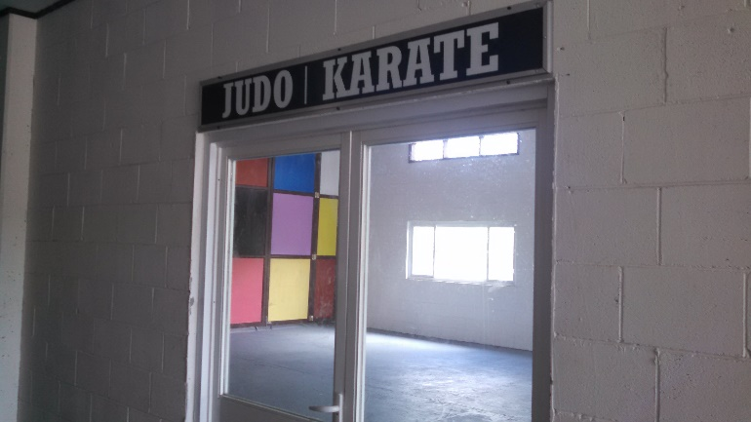

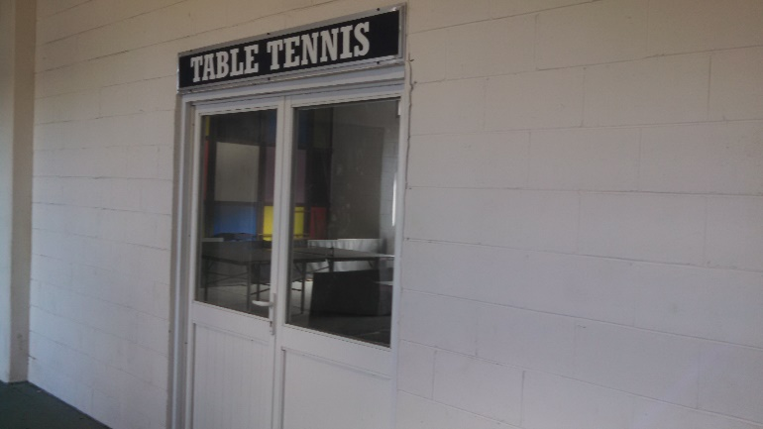

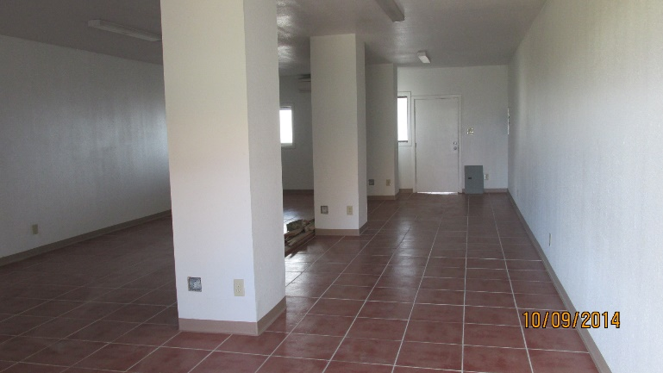

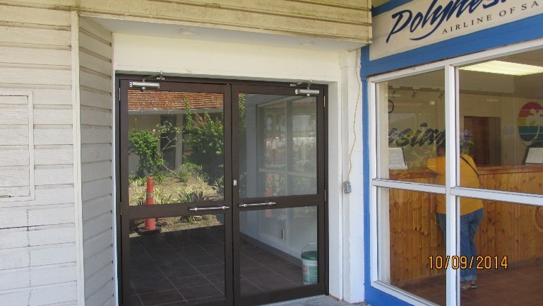
KVZK TV Building

Duration of project: 3 weeks
Cost of project: $800,000.00
Contractor: DPW M & O
Funded by: DOI – Capital Improvement Projects (CIP)

Pavaiai Elementary School
Bathroom Building

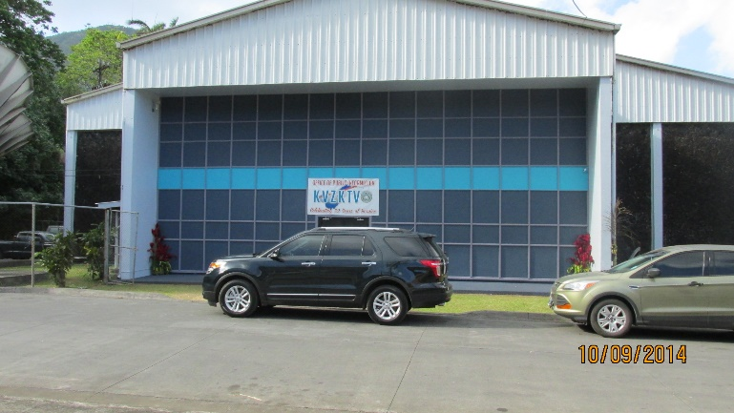

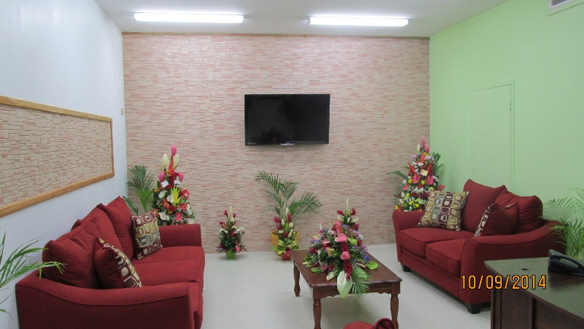

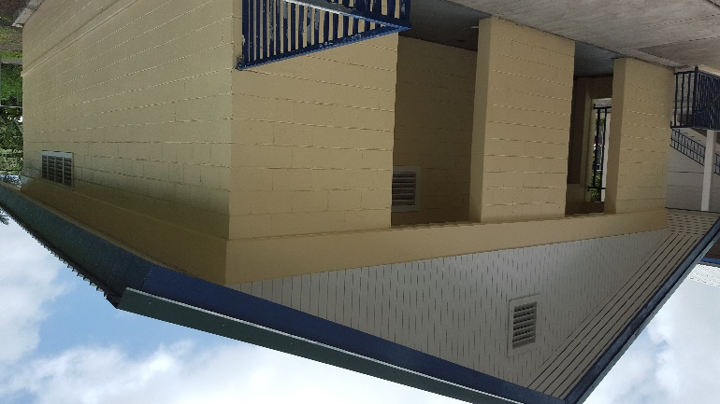

Improvements to Eastern and Western Sides of Tutuila

This project at the eastern and western sides of Tutuila is a temporary fix of Route 001 to Main Road from Laulii to Fagaitua Village and Futiga to Leone Bridge. It is a resurfacing of the road to improve traffic safety and condition of the road. It is a 2” thick of Hot Asphalt Concrete Pavement laid over the compacted and accepted subgrade according to Federal Highway standards and regulations.

Duration of project: 6 months
Cost of project: $3,730,987.59
Contractor: McConnell Dowell
Funding By: ASG local funds

